|  |  |  |
| --- | --- | --- |
| User story ID | User story title | Note |
| PROJ-5 | Verify Patient text field and character limits | Add scenario “User should not be able to enter invalid characters (symbols, special characters, numbers)”   1. Validate if user is able to enter symbols 2. Validate if user is able to enter special characters 3. Validate if user is able to enter numbers |
| PROJ-6 | Verify Patient name text field only allows English letters input for both uppercase and lowercase | This test case needs to be revised because case it can combine. |
| PROJ-7 | Verify Patient name text field only accepts letters | PROJ-7 can combine with PROJ-5 |
|  |  |  |
|  |  |  |
|  |  |  |
|  |  |  |

***Jacky,Selam, and Nicolay have not finished yet

*** Yeneth needs to create user story in Jira and add user story number to test case

*** Ricardo and Maximiliano need to add step for each scenario case.

*** Priya, I will combine test case

*** Be careful with the requirement that may not correct. For example: contact info, gender, frequency. If the requirements are incorrect that mean you will find bugs.

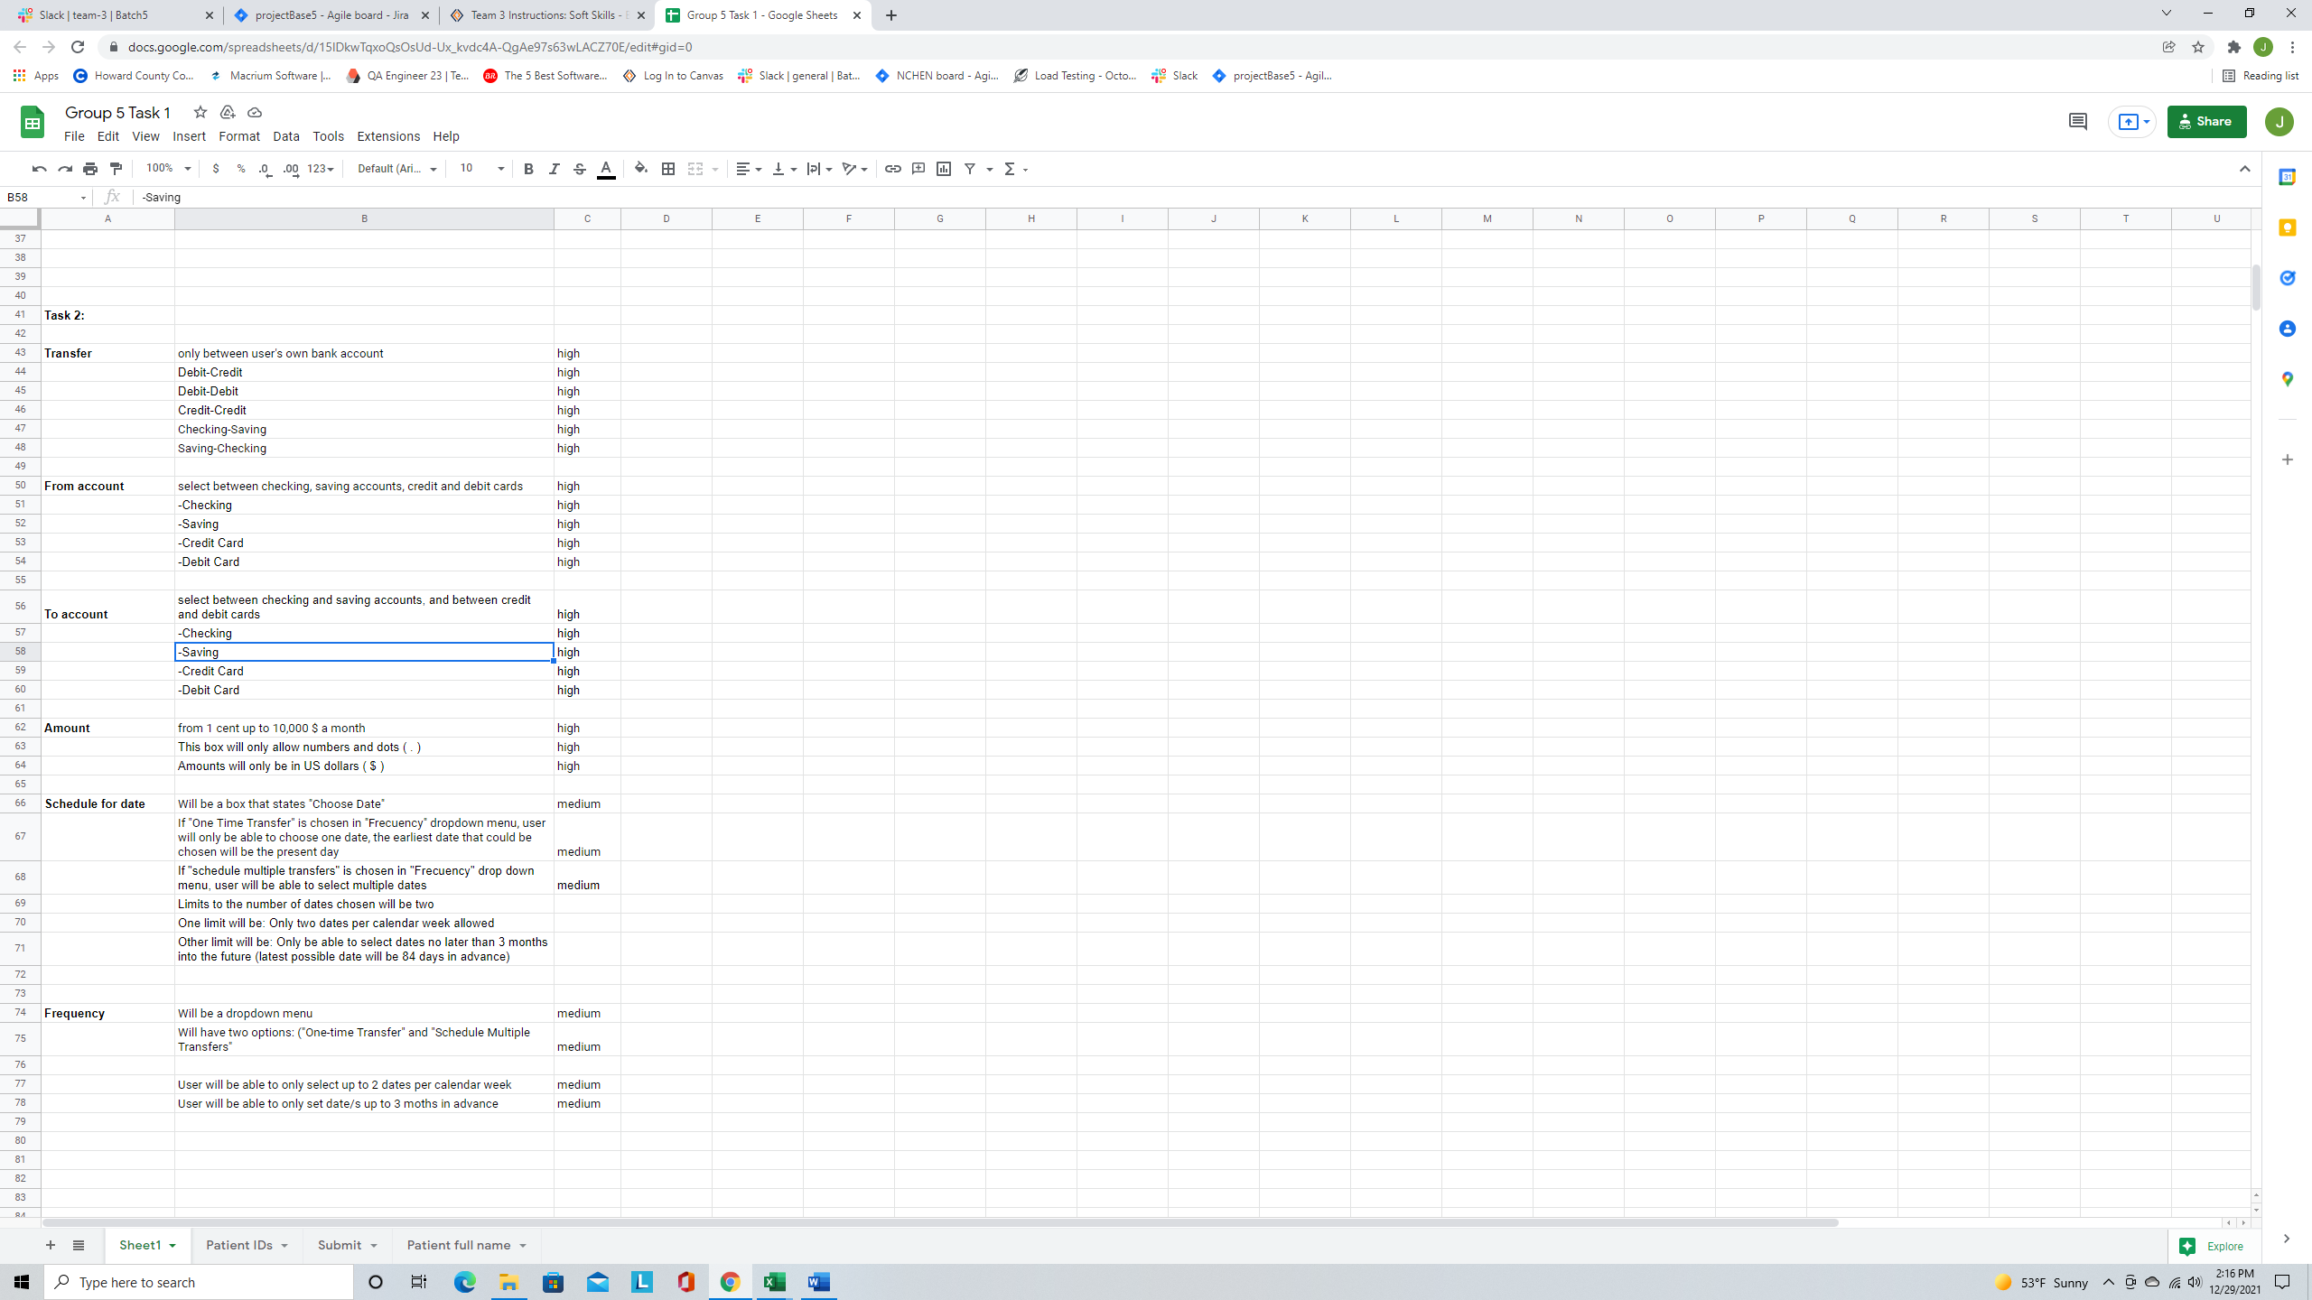



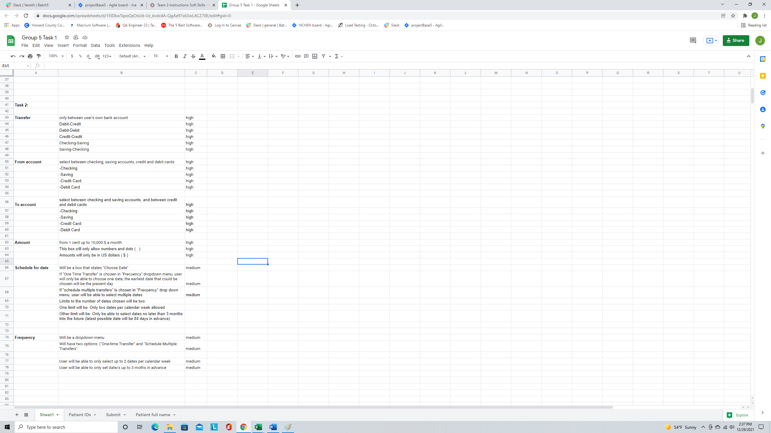



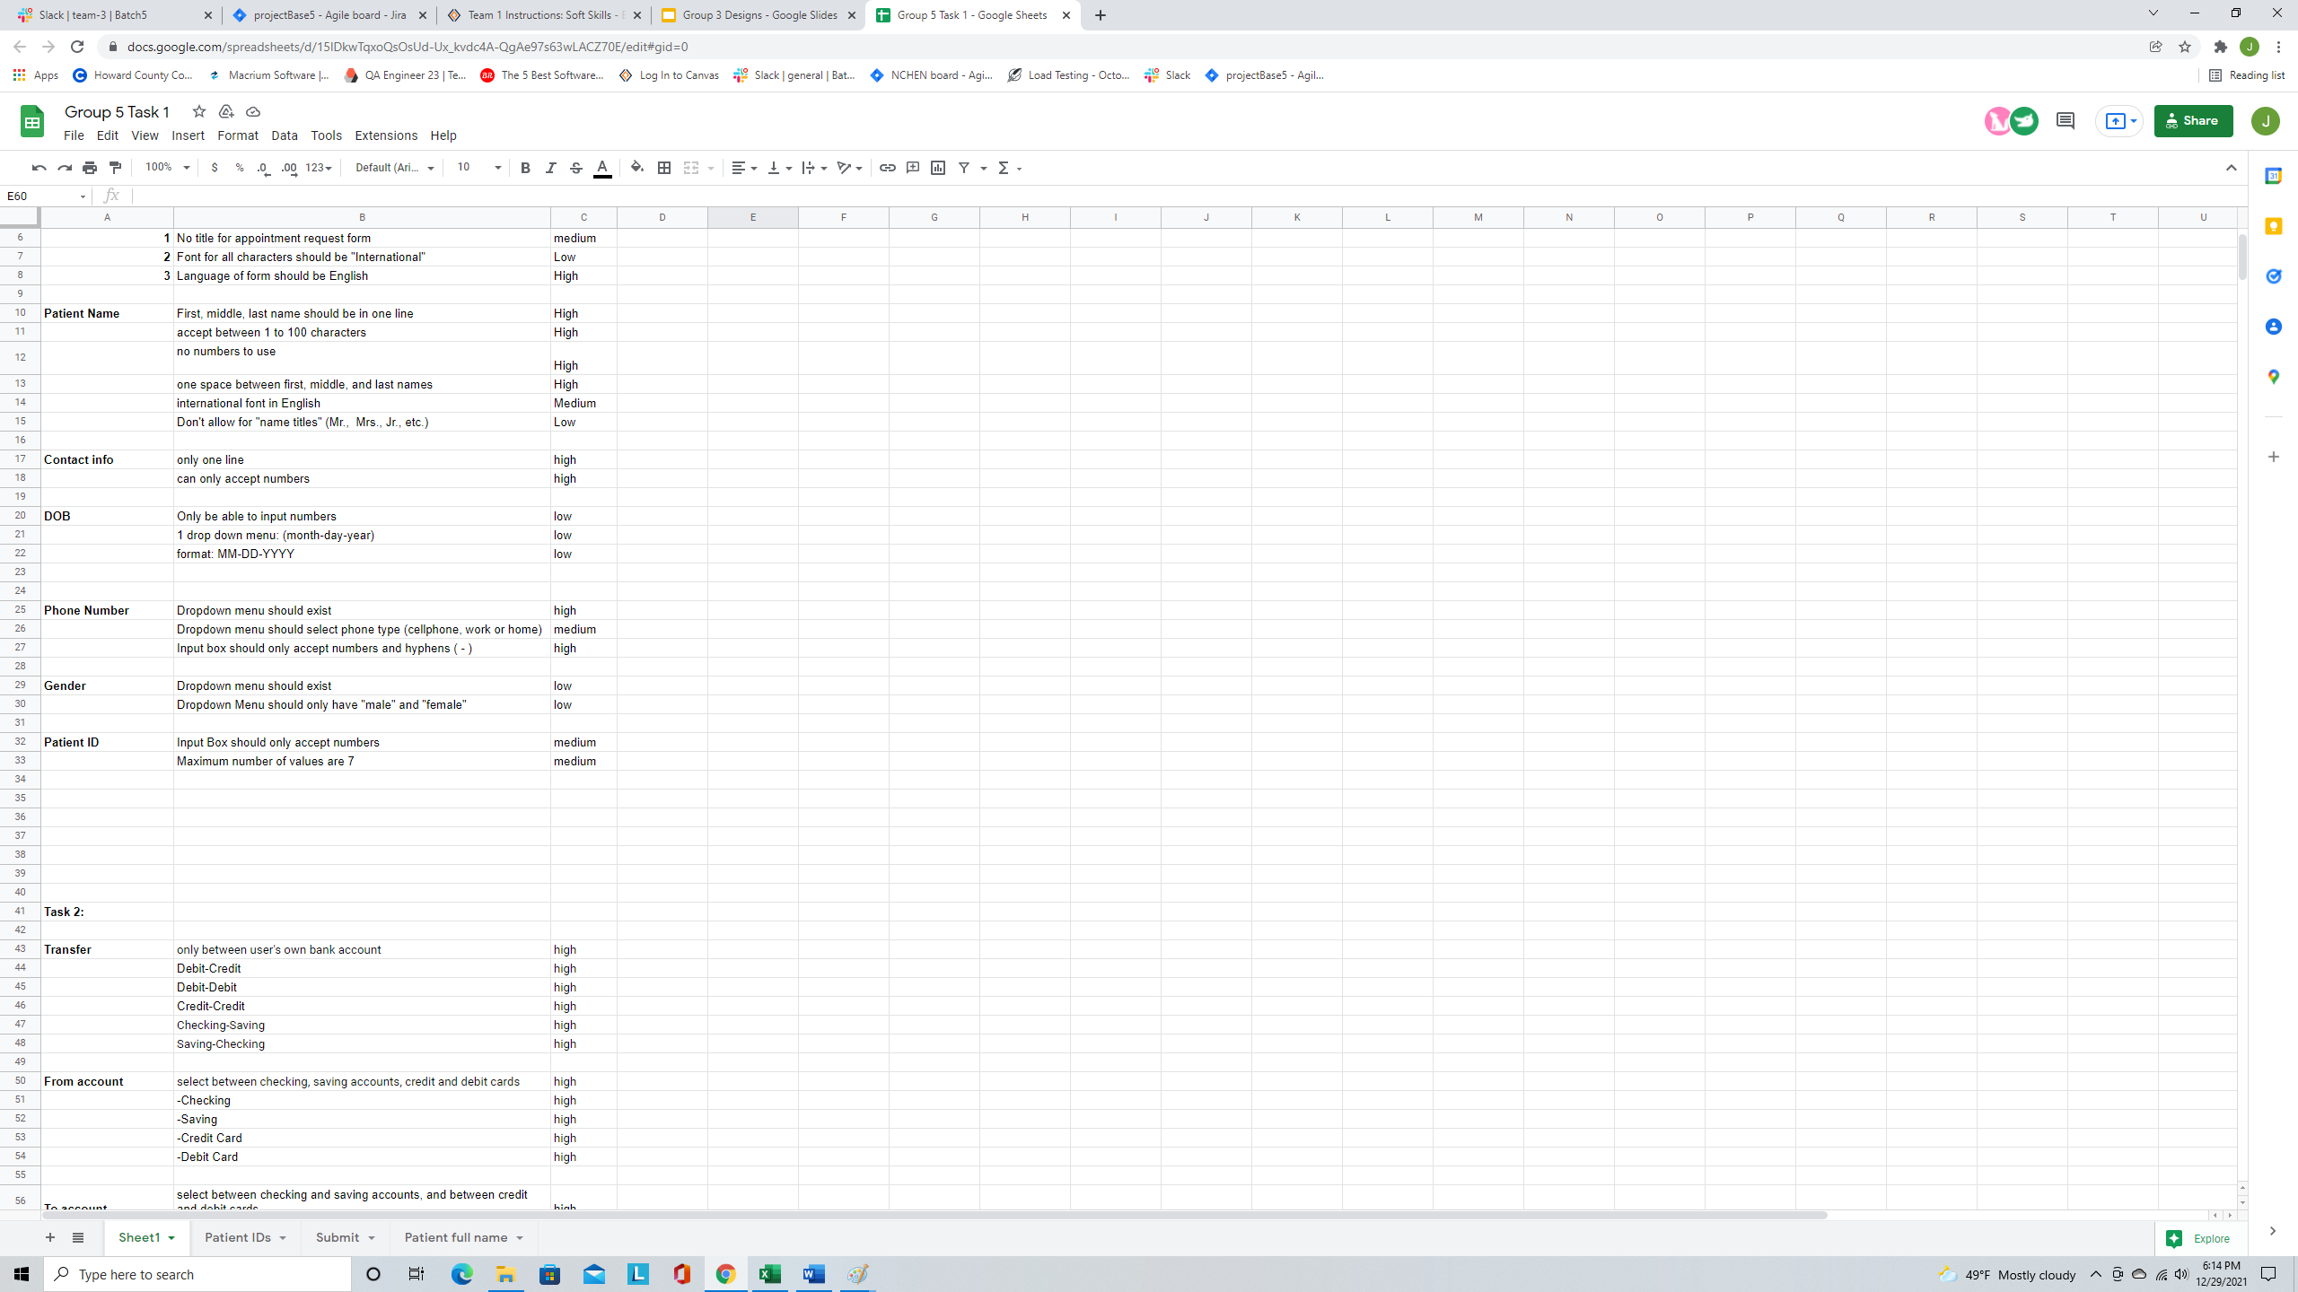

The correct requirement is “Dropdown menu should have 3 options “Male, Female, Other”

1. Topic for today meeting

* I’ve reviewed most of the test cases. Some test cases need to be revised prior to requirements are not correct.

1. Selam have not finished with all test case yet.
2. Could we finish with all test cases by tomorrow before class? Because I need time to review all of the test cases and select the cases for smoke testing and regression testing. Also, I have to prepare the presentation. I would like everybody to see the presentation in case you may want to change or edit something.
3. Please add Yes or No in the column smoke testing and regression testing in your test case (Excel sheet)
4. Does anybody see a user story number PROJ-10?

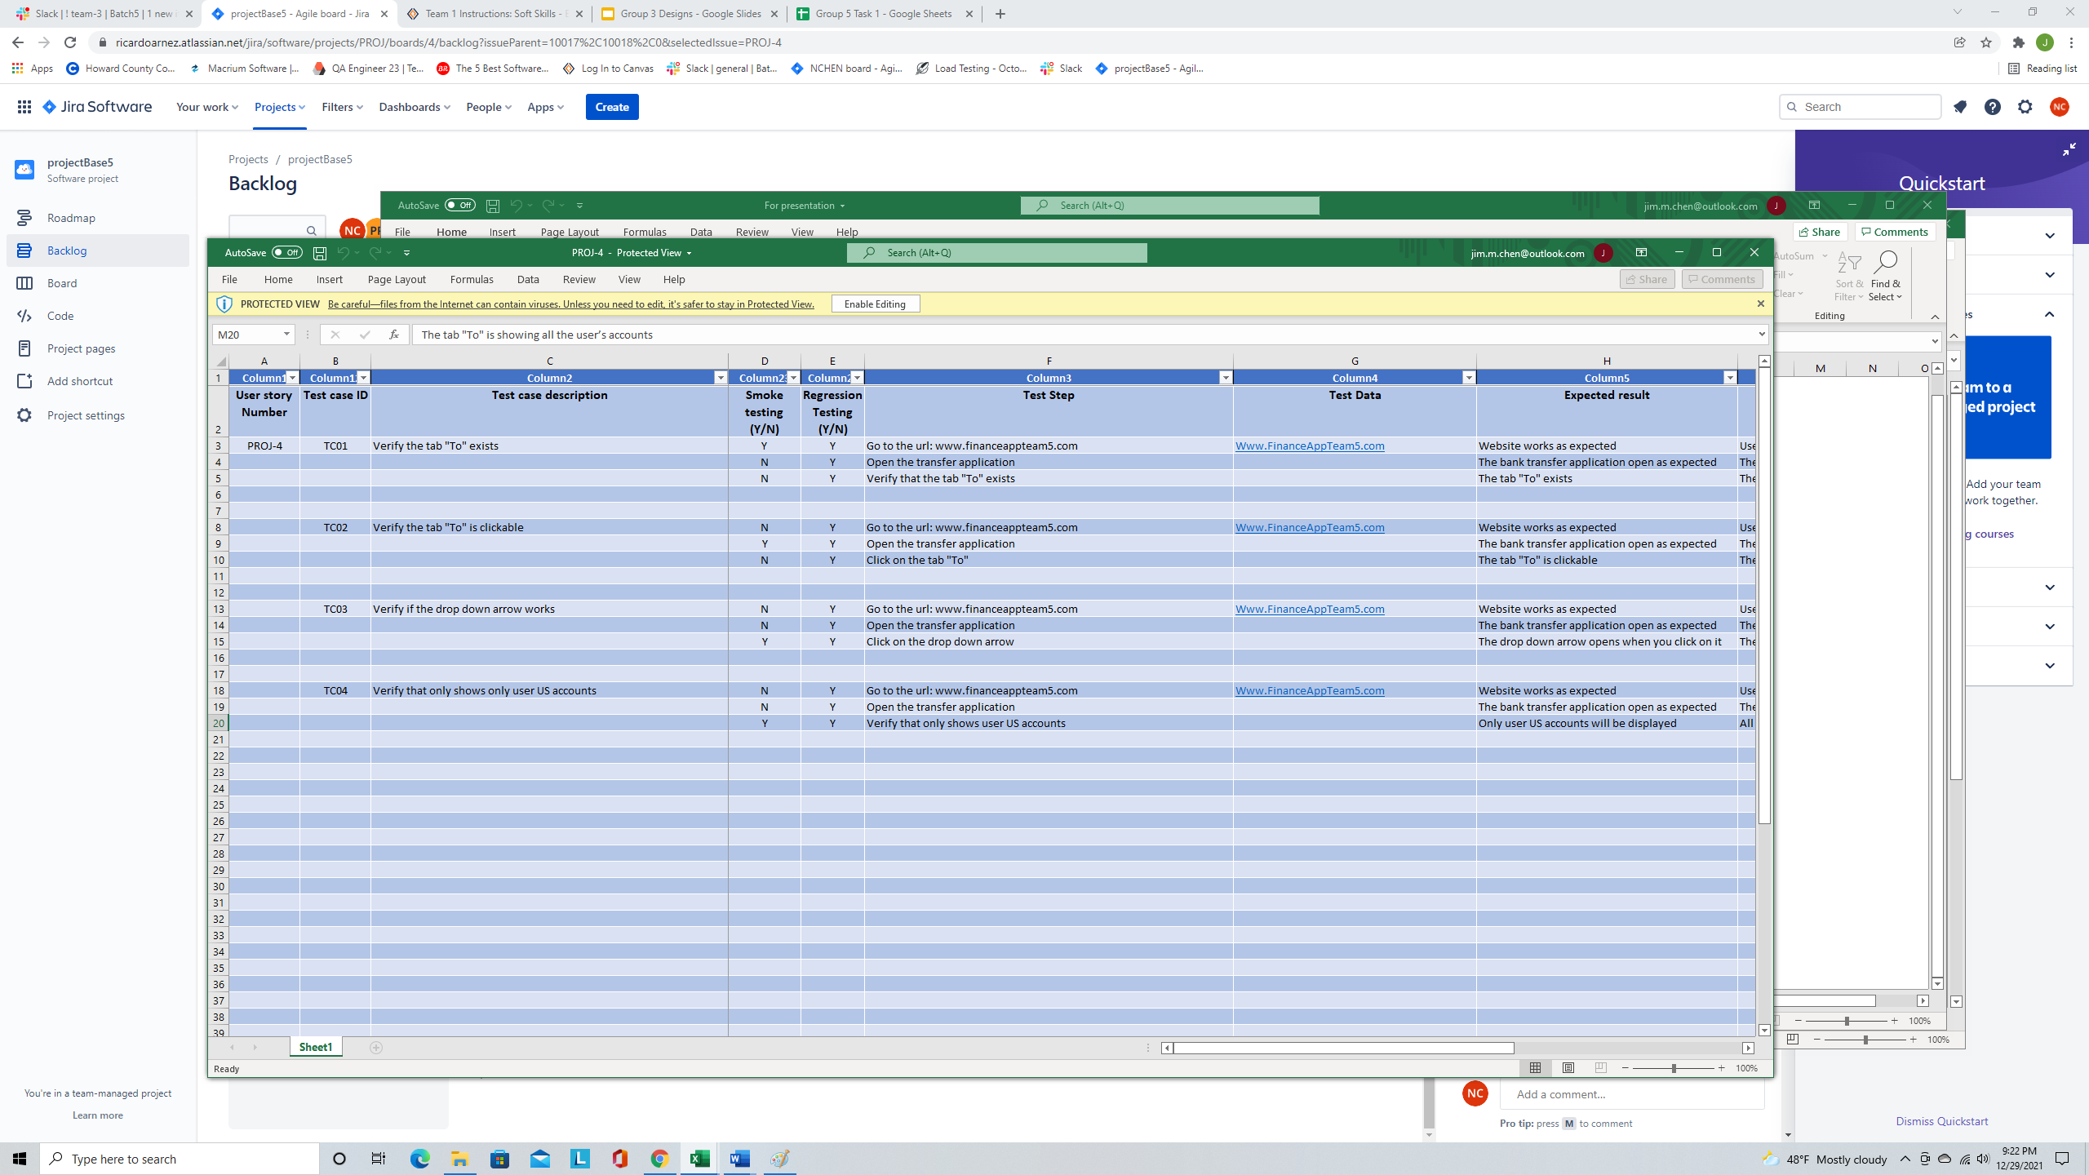

When you consider for smoke testing or regression testing, it’s going to be tested all steps in that scenario case, only one step in that scenario.

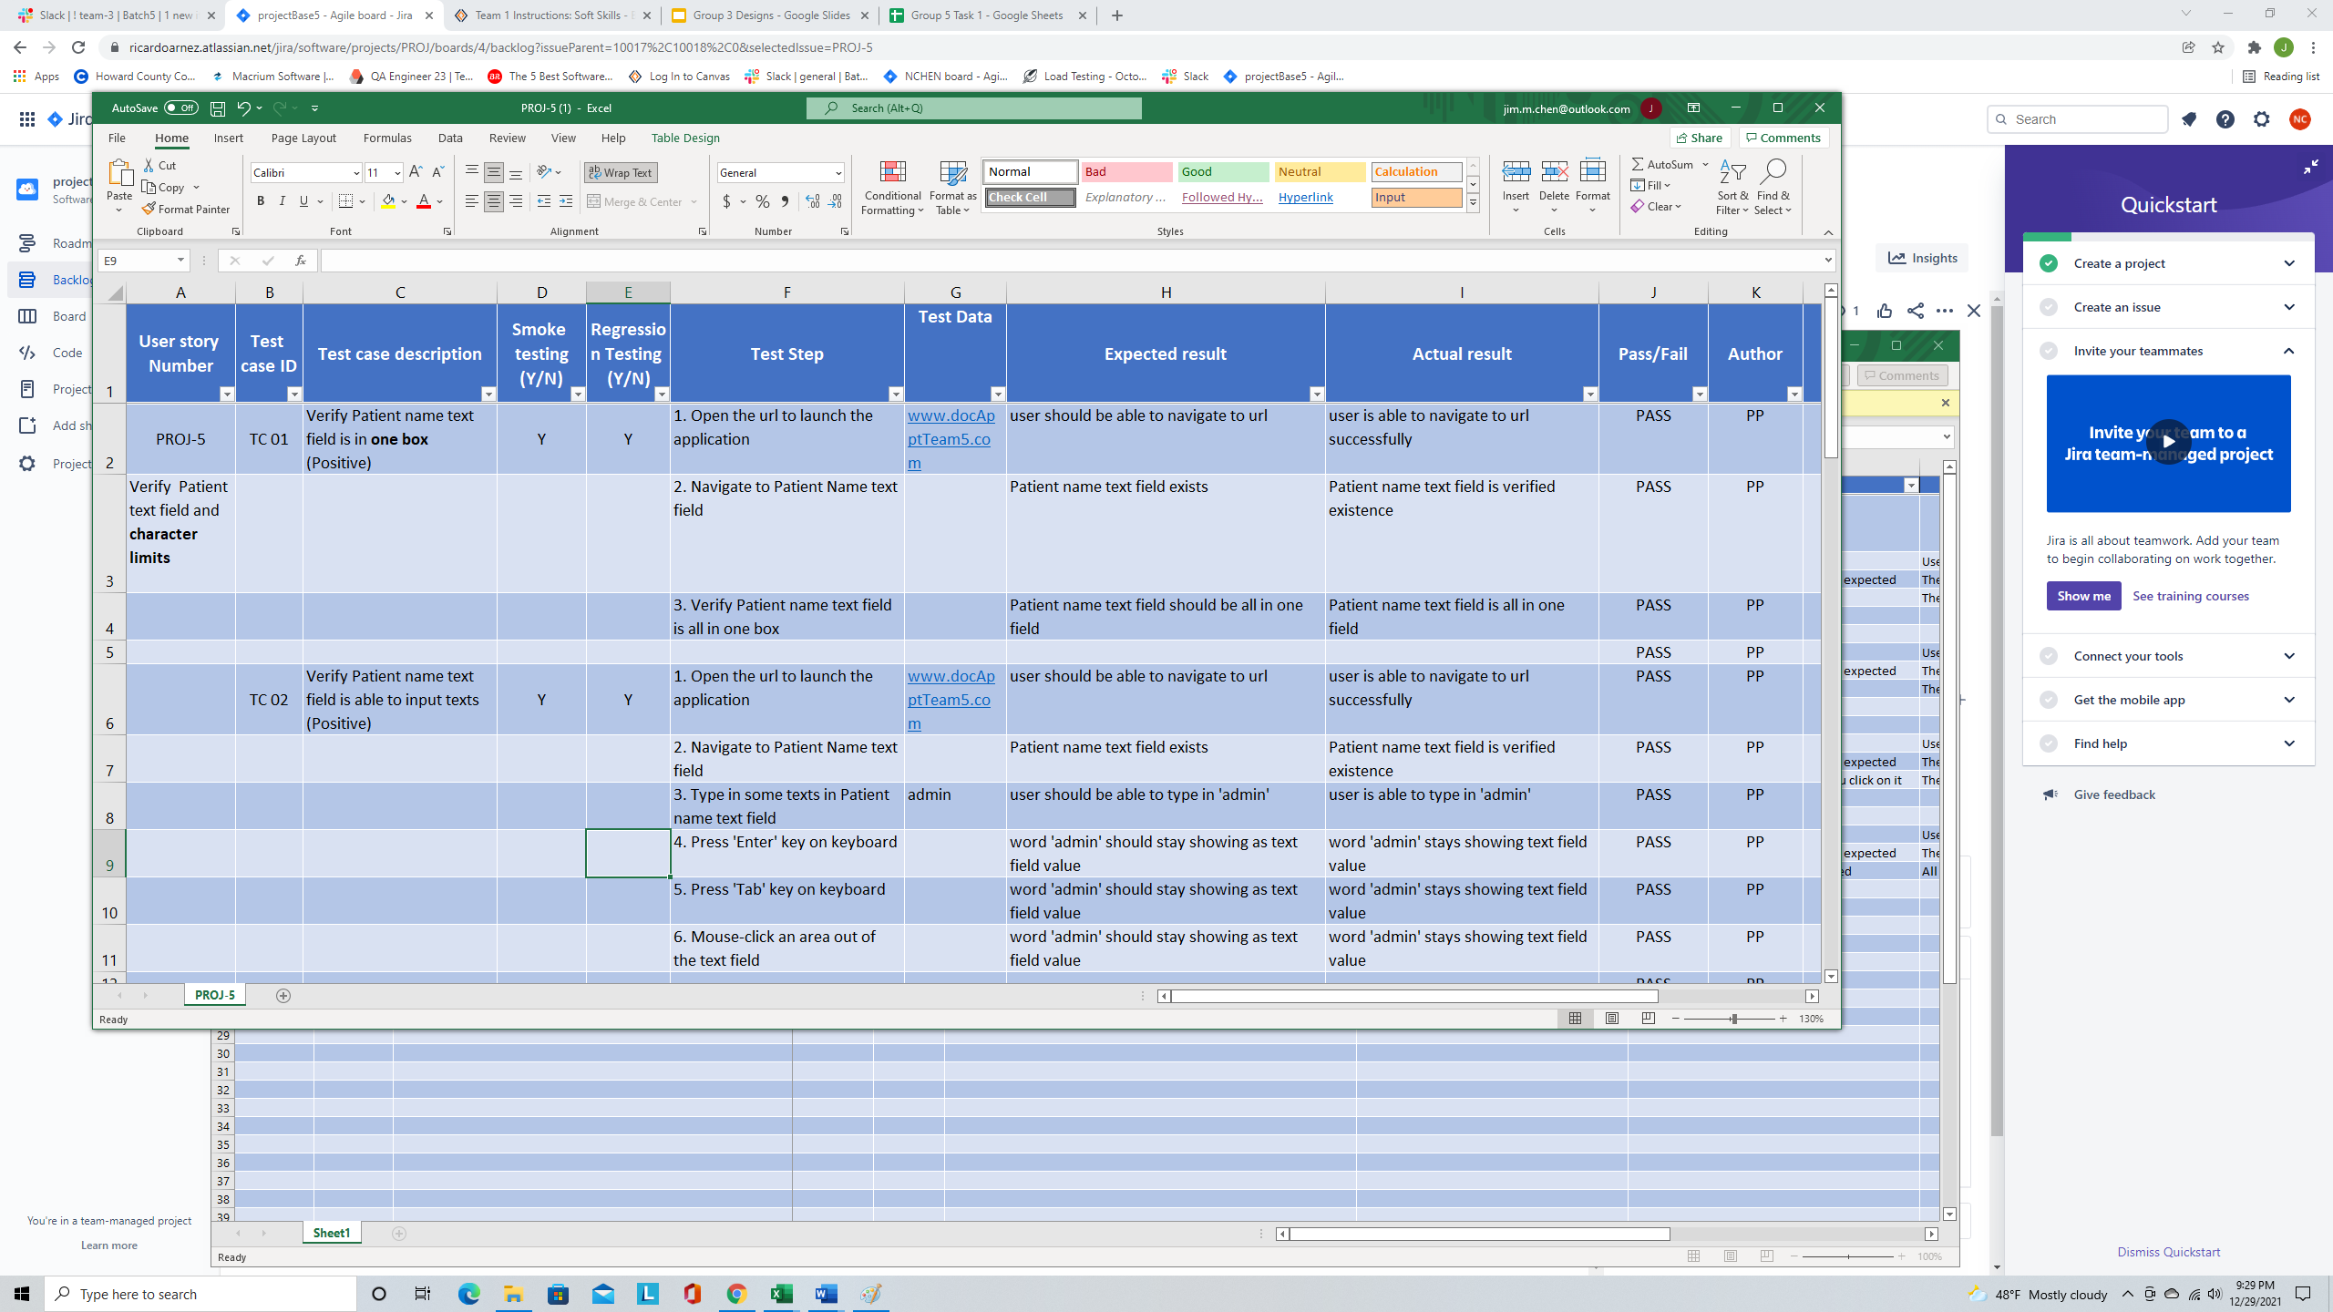

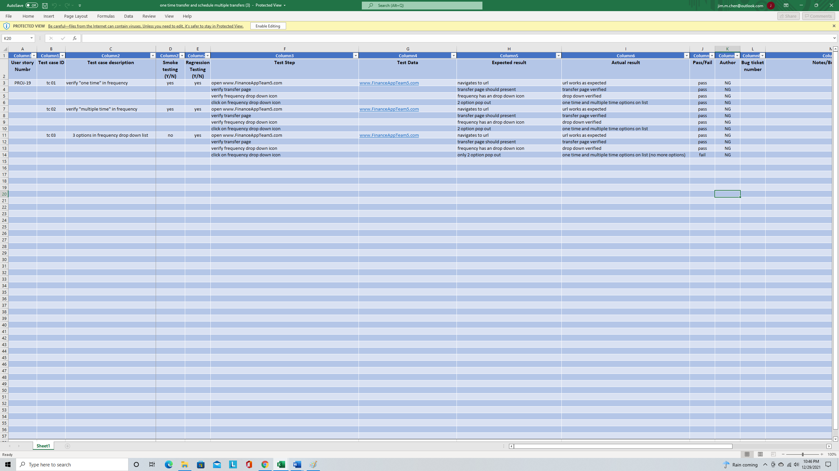



Is it a bug or not?